Title | Interactive Scatter Plot with Plotly
Problem Statement | Create an interactive scatter plot showing the relationship between house size and price.
Objectives
Dataset  URL Link /  File | 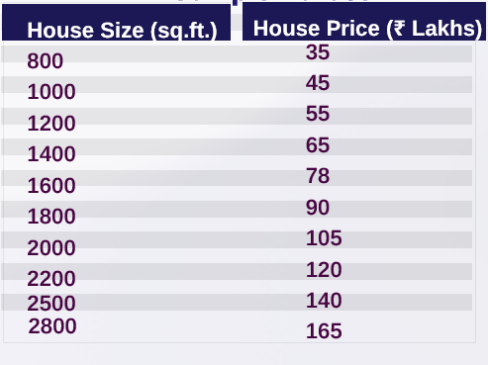
Functions  Details | Sl. No. | Function | Package | Description of function
 | 1
 | 2
 | 3
 | 4
 | 5
 | 6
 | 7
 | 8
 | 9
 | 10
 | 11
 | 12
Steps/
Process/
Procedure/
Algorithm/
Flowchart/
Model

Program
Output Snapshots
With
Explanation/
Observations
Conclusions
References | - Michael Freeman and Joel Ross, Programming Skills for Data Science: Start Writing Code to Wrangle, Analyze, and Visualize Data with R, Addison-Wesley, 2018  - Python Program (Google Colab link /Githab link)  - Class lecture link

